Introduction to Amazon DynamoDB

Alen Ovalles

Purpose

This lesson aims to get introduced to DynamoDB by creating a Dynamo table as a proof of concept. The lab will allow us to populate the table with objects and their attributes to gain insight into how the database works.

Process with Pictures

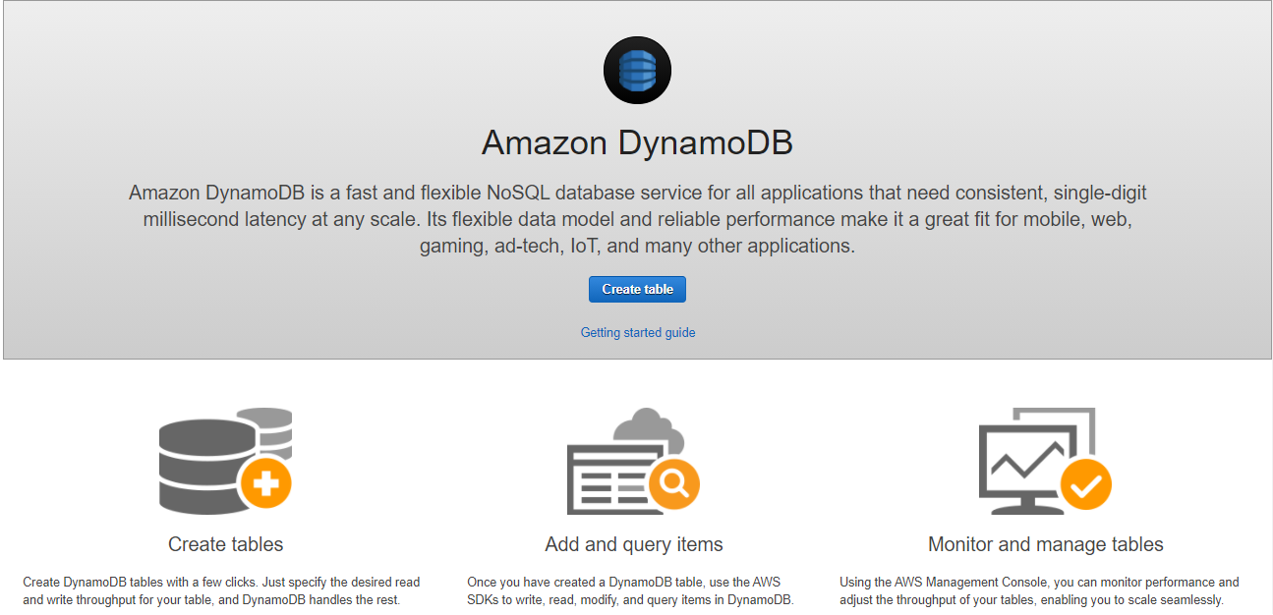

**Step 1:** Navigate to the DynamoDB service and click Create table

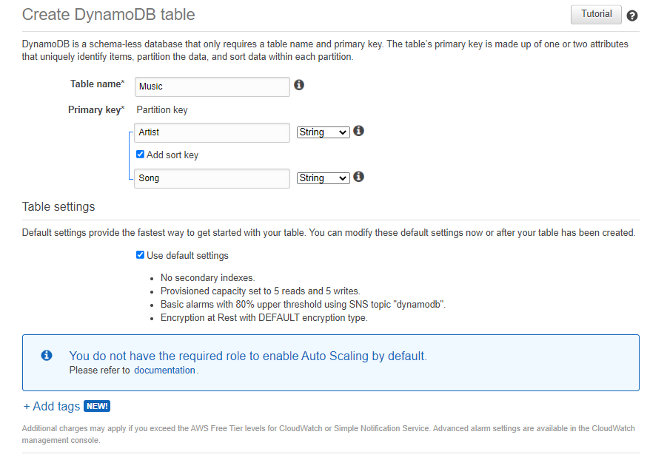

**Step 2:** Table name: Music | Primary key: Artist, String | Sort key: Song, String

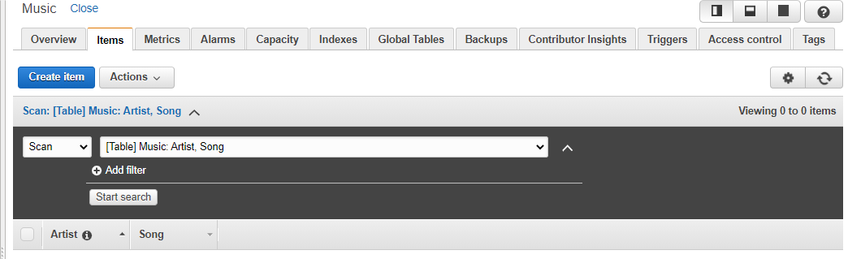

**Step 3:** Navigate to the Items tab and click Create Item button

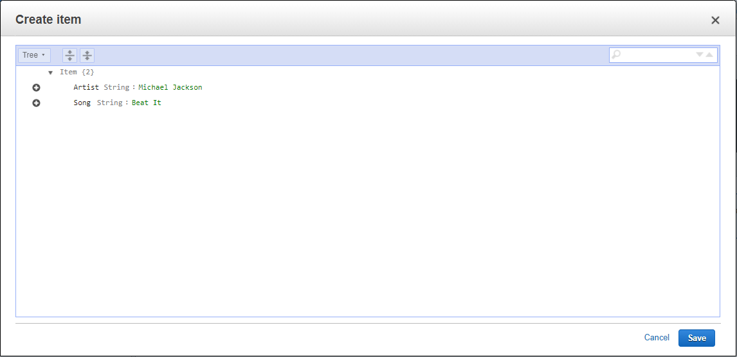

**Step 4:** Artist: Michael Jackson | Song: Beat It

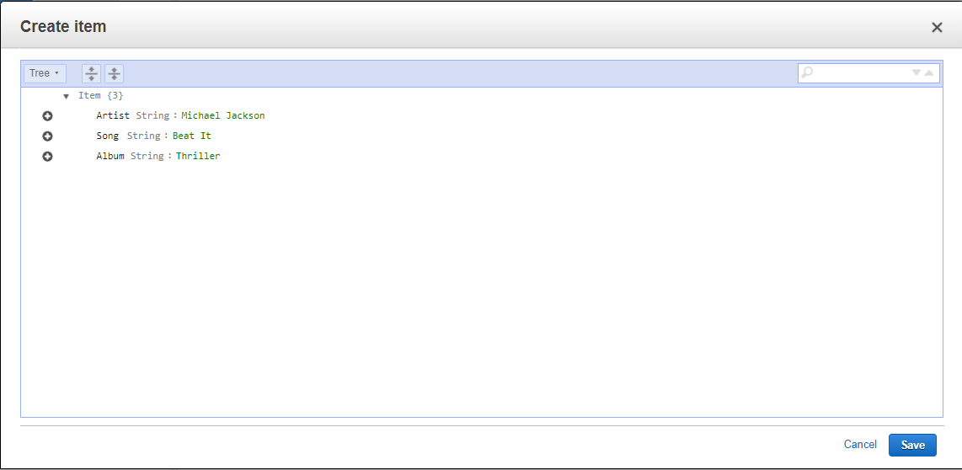

**Step 5:** Add additional attributes by clicking the + sign and select the type of item;

Ex. Album String: Thriller

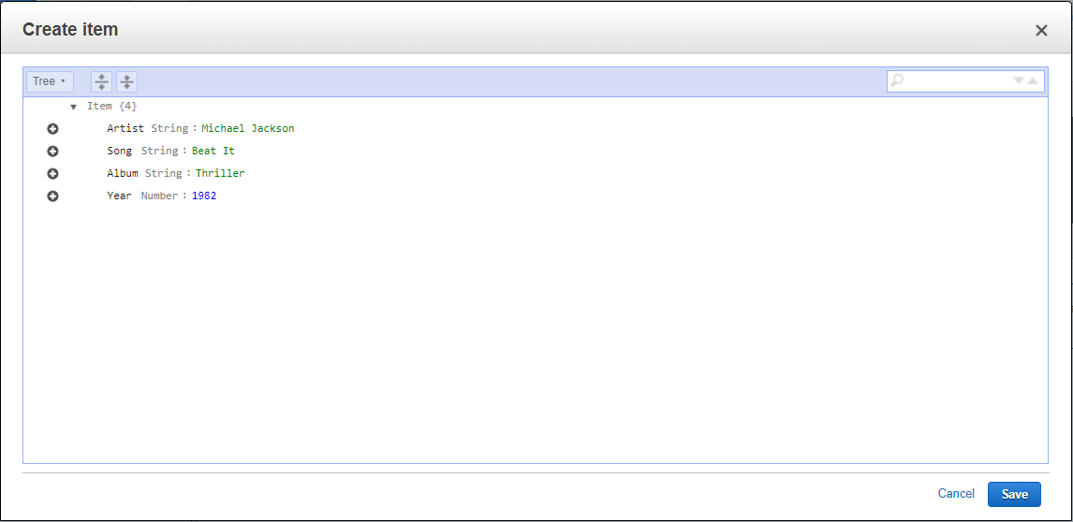

**Step 6:** Add a number item | Year Number: 1982

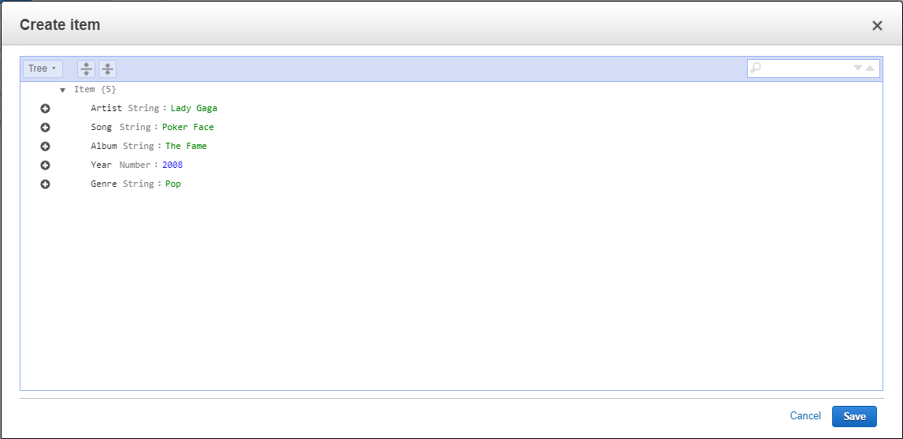

**Step 7:** Create a second item; Artist String: Lady Gaga | Song String: Poker Face | Album String: The Fame | Year Number: 2008 | Genre String: Pop

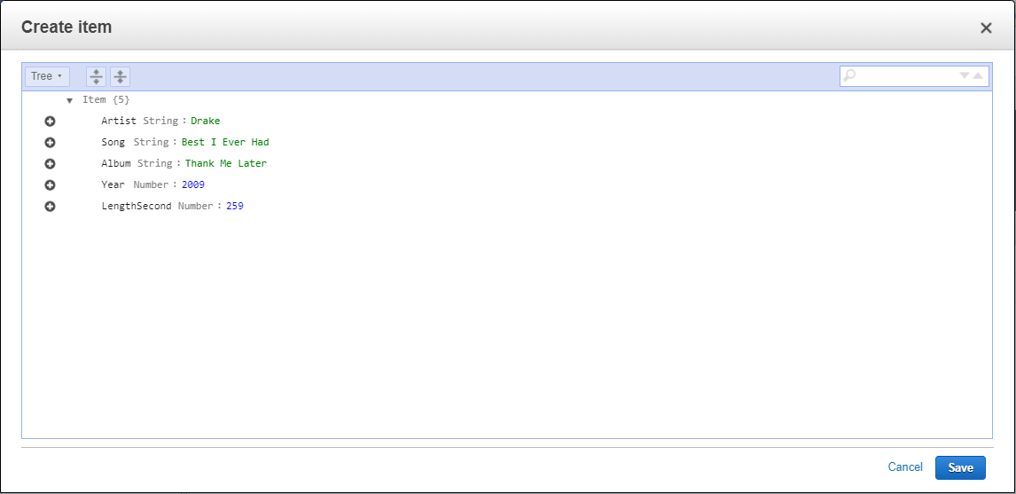

**Step 8:** Create a third item; Artist String: Drake | Song String: Best I Ever Had |

Album String: Thank Me Later | Year Number: 2009 | LengthSecond Number: 259

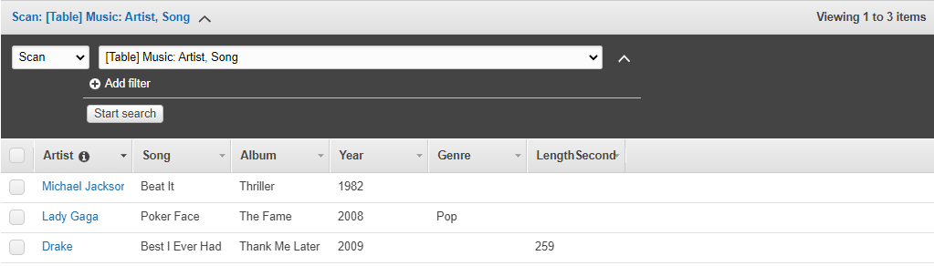

**Step 9:** Notice the flexibility of the NoSQL database with the different data

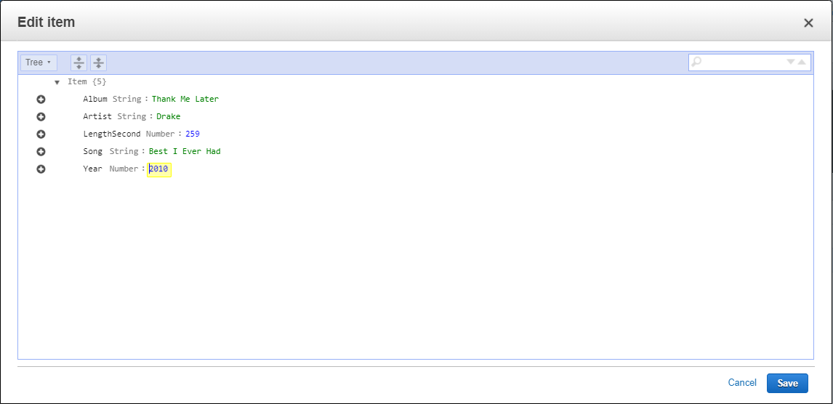

**Step 10:** Click the item Drake and update the year to 2010

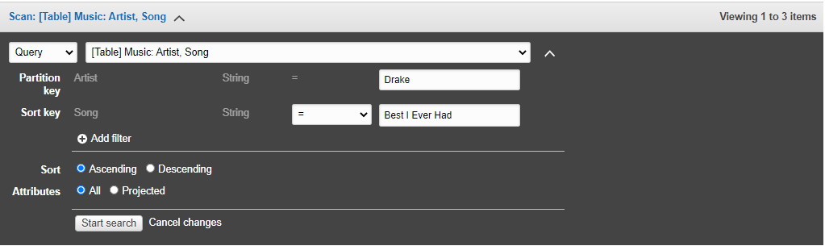

**Step 11:** Click the drop-down list showing scan and change it to Query

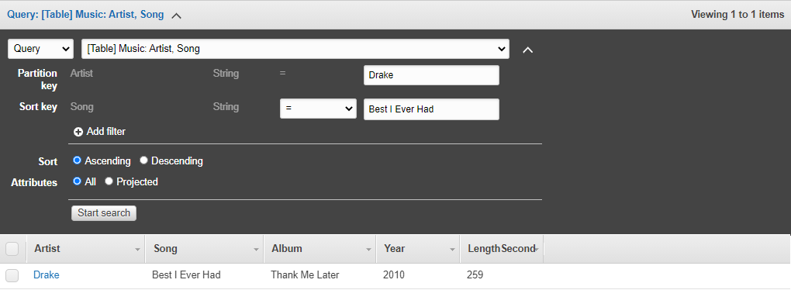

**Step 12:** Enter details; Partition key: Drake | Sort key: Best I Ever Had

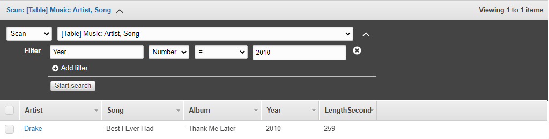

**Step 13:** Switch back to Scan and enter new details; Enter attribute: Year |

Change *string* to Number | Enter value: 2010

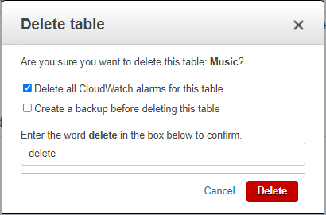

**Step 14:** Delete the Music table when done with the task

Problems

There were no real problems with this lab as it introduced the new service: DynamoDB for the first time, very straightforward.